**Salesforce Project Implementation Phases**

**Phase 8: Data Management & Deployment**

Managing Salesforce data and deploying configurations across environments is crucial for maintaining data integrity and smooth release cycles.

* **Data Import Wizard**

The Data Import Wizard is a simple, browser-based tool that allows admins to import data into Salesforce without writing code. It is best suited for smaller datasets (up to 50,000 records).

Key Features

- Supports Standard Objects (Leads, Accounts, Contacts, Solutions, Campaign

Members) and Custom Objects.

- Provides an intuitive step-by-step interface.

- Allows mapping of CSV fields to Salesforce fields.

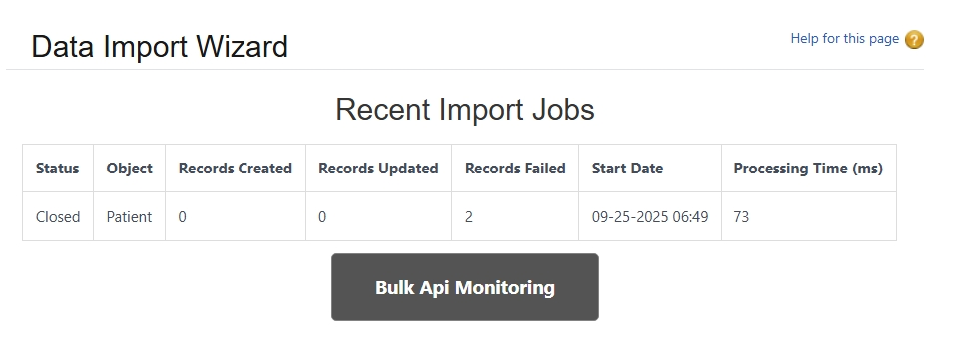



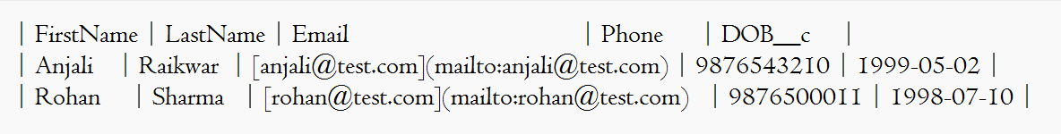

* **Data Loader**

The Salesforce Data Loader is a client application used for bulk data operations (up to 5 million records). It provides more control and is ideal for larger datasets.

Key Features

- Supports Insert, Update, Upsert, Delete, Export.

- Works with CSV files.

- Can be scheduled via CLI for automation.

* **Duplicate Rules**

Duplicate Rules prevent creation of duplicate records, thereby ensuring data quality. These rules can block duplicates or alert users when similar records already exist.

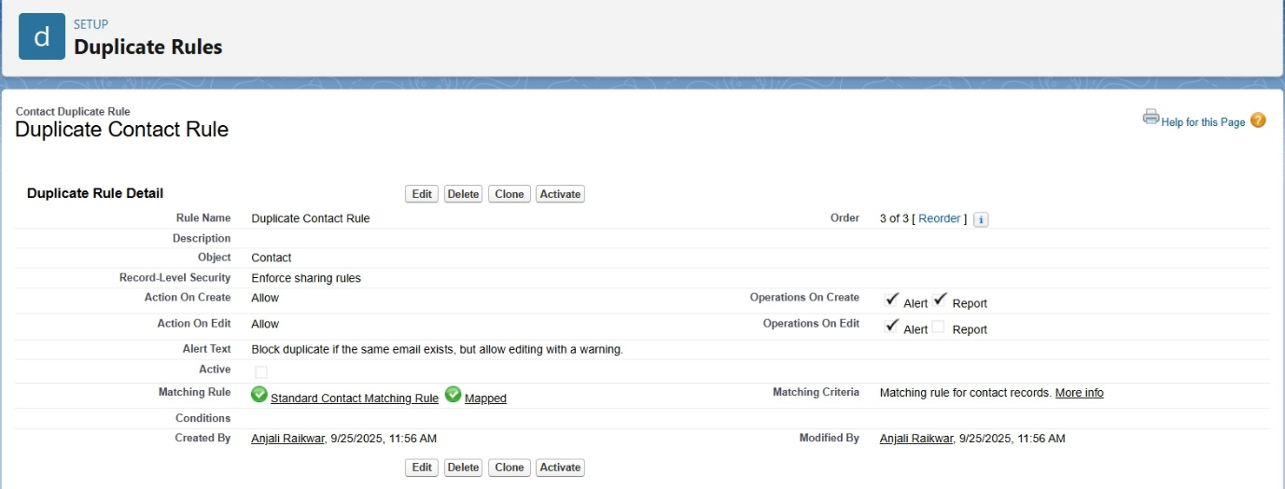

* **Data Export & Backup**

Salesforce allows exporting full datasets for backup or compliance. Exports can be scheduled weekly or monthly.

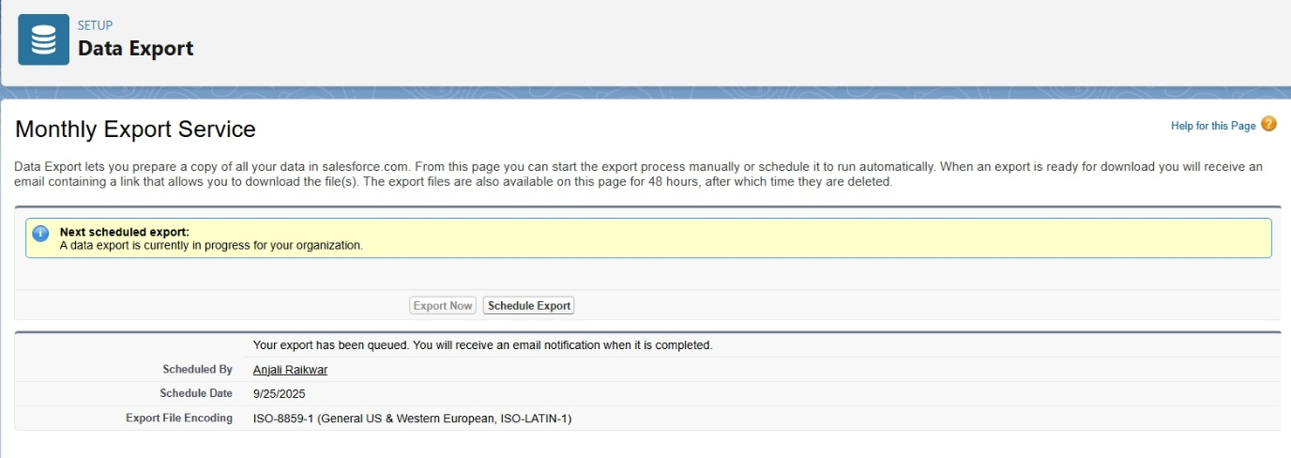

* **Change Sets**

Change Sets are Salesforce’s point-and-click tool for moving metadata (custom fields, objects, Apex, Flows, etc.) between environments like Sandbox → Production.

* **Unmanaged vs Managed Packages**

Packages are used to group components for distribution.

- Unmanaged Package:

* + Components are editable after installation.
  + Ideal for one-time deployments or sharing code.

- Managed Package:

* + Code is locked after installation.
  + Supports versioning and upgrade paths.
  + Required for AppExchange distribution.

**Change Sets**: Used to move metadata between related Salesforce orgs (Sandbox → Production).  
Not available in Developer Edition (since it has no Sandbox). For this project, we demonstrate deployment using **VS Code (SFDX)** instead.

* **ANT Migration Tool**

The ANT Migration Tool is a Java/Apache ANT-based tool that enables scripted deployments between Salesforce orgs. It is powerful for CI/CD automation.

**- build.properties**

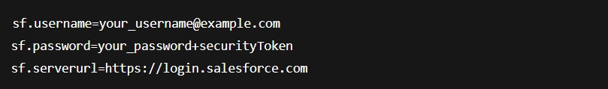

**- package.xml**

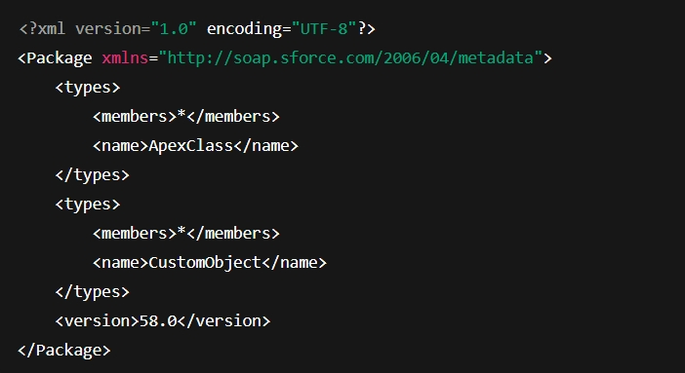

**- build.xml**

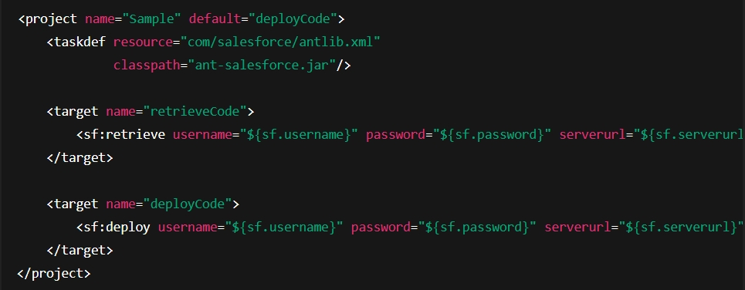

* retrieveCode → pulls metadata from org.
* deployCode → pushes metadata to org.
* **VS Code & SFDX (Salesforce DX)**

Salesforce DX (SFDX) with Visual Studio Code is the modern way to develop and deploy Salesforce applications. It enables source-driven development, version control, scratch orgs, and CI/CD.